Lab 3: Web API using Custom Model Class and Custom Filters
Objective
To create an ASP.NET Core Web API using a custom model class, implement GET, POST, and PUT action methods, demonstrate the use of the FromBody attribute, apply custom authorization and exception filters, and test the API using Swagger.
Commands Used
dotnet new webapi --use-controllers -n FirstWebAPI
cd FirstWebAPI
dotnet run
Code
Program.cs
using FirstWebAPI.Filters;
using Microsoft.OpenApi.Models;
var builder = WebApplication.CreateBuilder(args);
builder.Services.AddControllers(options =>
{
options.Filters.Add<CustomExceptionFilter>();
});
builder.Services.AddEndpointsApiExplorer();
builder.Services.AddSwaggerGen(options =>
{
options.SwaggerDoc("v1", new OpenApiInfo
{
Title = "Employee API",
Version = "v1",
Description = "Employee Web API with Custom Filters"
});
});
var app = builder.Build();
app.UseSwagger();
app.UseSwaggerUI();
app.UseHttpsRedirection();
app.UseAuthorization();
app.MapControllers();
app.Run();
Employee.cs
namespace FirstWebAPI.Models;
public class Employee
{
public int Id { get; set; }
public string Name { get; set; }
public int Salary { get; set; }
public bool Permanent { get; set; }
public Department Department { get; set; }
public List<Skill> Skills { get; set; }
public DateTime DateOfBirth { get; set; }
}
Department.cs
namespace FirstWebAPI.Models;
public class Department
{
public int Id { get; set; }
public string Name { get; set; }
}
Skill.cs
namespace FirstWebAPI.Models;
public class Skill
{
public int Id { get; set; }
public string Name { get; set; }
}
EmployeeController.cs
using Microsoft.AspNetCore.Authorization;
using Microsoft.AspNetCore.Mvc;
using FirstWebAPI.Filters;
using FirstWebAPI.Models;
namespace FirstWebAPI.Controllers;
[ApiController]
[Route("api/[controller]")]
[CustomAuthFilter]
public class EmployeeController : ControllerBase
{
private List<Employee> employees;

public EmployeeController()
{
employees = GetStandardEmployeeList();
}
private List<Employee> GetStandardEmployeeList()
{
return new List<Employee>
{
new Employee
{
Id = 1,
Name = "Harshitha",
Salary = 50000,
Permanent = true,
Department = new Department
{
Id = 1,
Name = "IT"
},
Skills = new List<Skill>
{
new Skill { Id = 1, Name = "C#" },
new Skill { Id = 2, Name = "ASP.NET Core" }
},
DateOfBirth = new DateTime(2003, 5, 10)
}
};
}
[AllowAnonymous]
[HttpGet]
[ProducesResponseType(StatusCodes.Status200OK)]
[ProducesResponseType(StatusCodes.Status500InternalServerError)]
public ActionResult<List<Employee>> GetStandard()
{
return Ok(employees);
}

[HttpPost]
public IActionResult AddEmployee([FromBody] Employee employee)
{
employees.Add(employee);
return Ok(employee);
}
[HttpPut]
public IActionResult UpdateEmployee([FromBody] Employee employee)
{
return Ok(employee);
}
}
Output
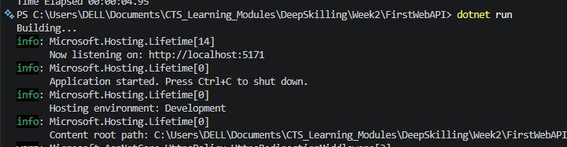
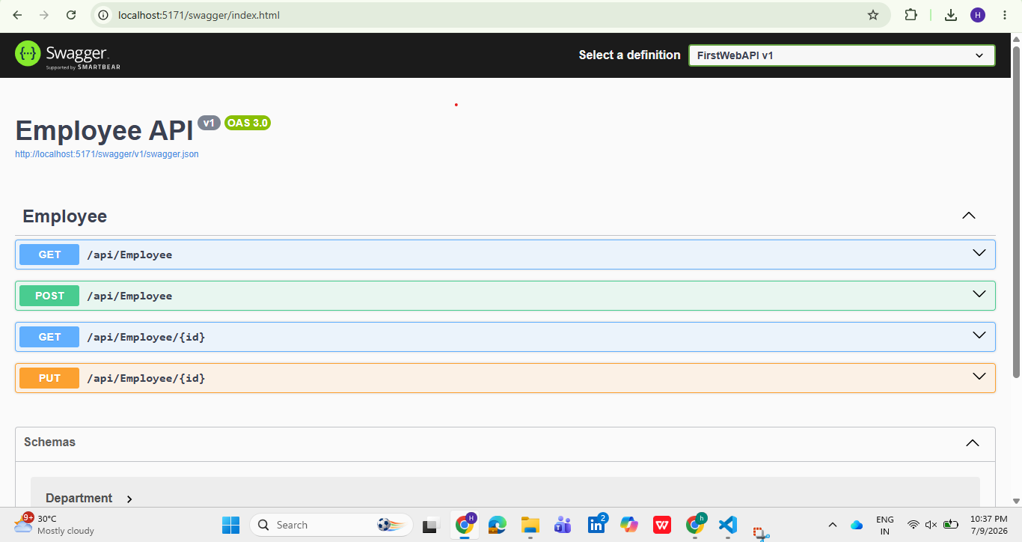
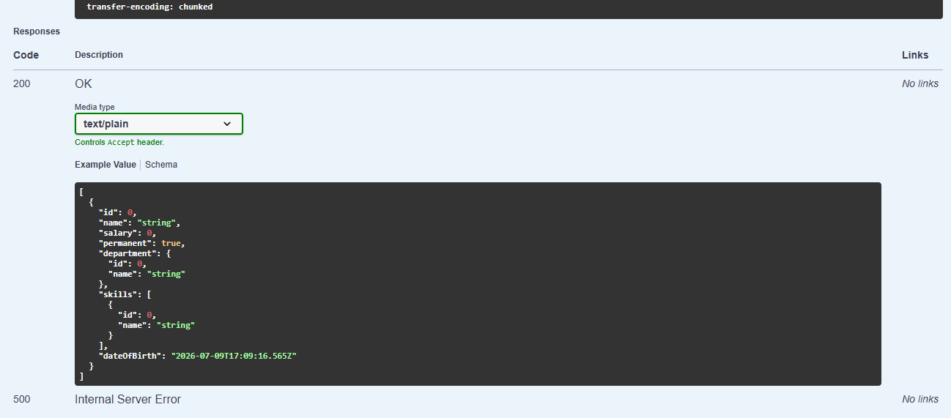
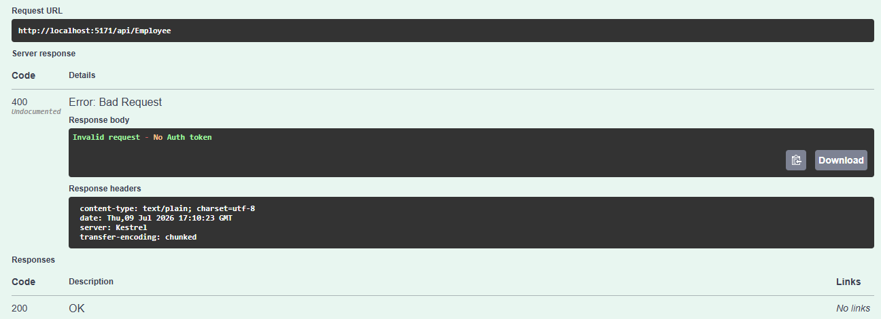
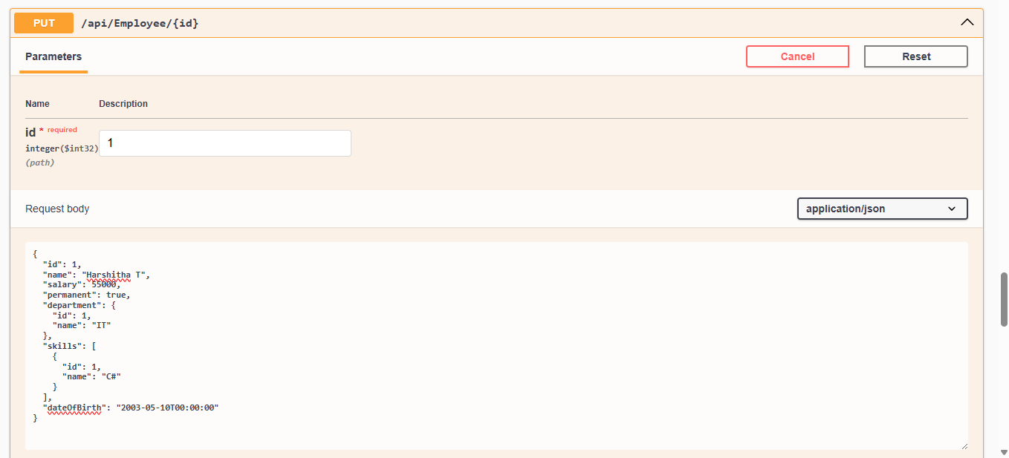
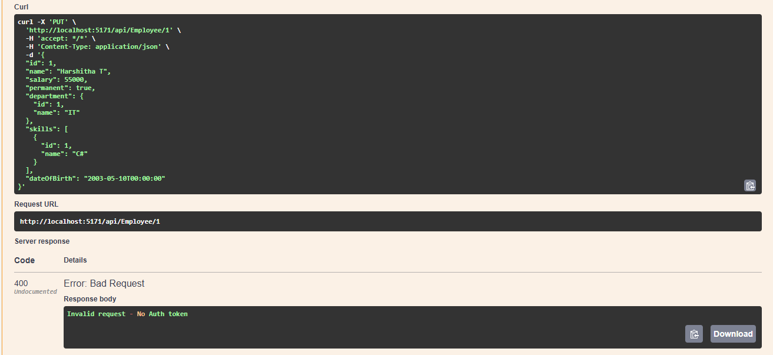
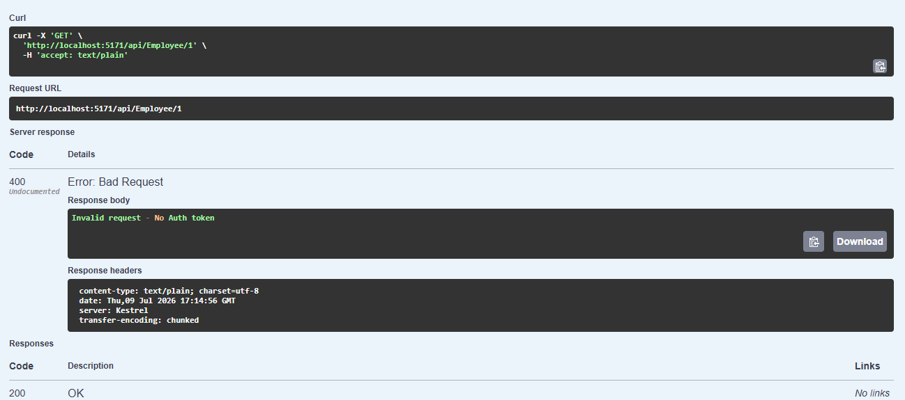
Result
A custom ASP.NET Core Web API was successfully implemented using a custom Employee model. The API supported GET, POST, and PUT operations, demonstrated model binding using the FromBody attribute, and was tested using Swagger. A custom authorization filter validated the Authorization header before processing requests, while a custom exception filter handled runtime exceptions, logged them to a file, and returned a standardized 500 Internal Server Error response. This demonstrated the use of custom models, action methods, filters, and exception handling in ASP.NET Core Web API.

